Automation Exercise - Functional Test Report

Module Name: Automation Exercise - Website Functional Test Cases
Test Case ID: TC-002
Tester Name: Fegade Parth
Test Case Description: To validate the functionality of login, signup, product browsing, cart, checkout, and contact us workflows on the Automation Exercise website.
Prerequisites: 1. Stable internet connection 2. Browsers for cross browser testing 3. Valid URL for the Automation Exercise website 4. Test user credentials
Environment Information: Webpage URL: https://automationexercise.com/

Scenario ID: TC-001
Scenario: Login Module
Test Steps: Verify successful login with valid credentials
Test Input: Email: testuser@example.com
Password: Test@1234
Expected Results: User should be logged in successfully and redirected to Home page. 'Logged in as username' should be displayed.
Actual Results: User logged in successfully. 'Logged in as Test User' message appeared on top navigation.
Status: Pass
Comments: Login works as expected. Good feedback message. Consider adding 'Remember Me' option for better UX.

Scenario ID: TC-002
Scenario: Login Module
Test Steps: Verify login with invalid password
Test Input: Email: testuser@example.com
Password: WrongPass123
Expected Results: Error message 'Your email or password is incorrect!' should be displayed. User should remain on login page.
Actual Results: Error message displayed correctly: 'Your email or password is incorrect!'. Stayed on login page.
Status: Pass
Comments: Error handling is clear and user-friendly. Good practice.
Screenshots:
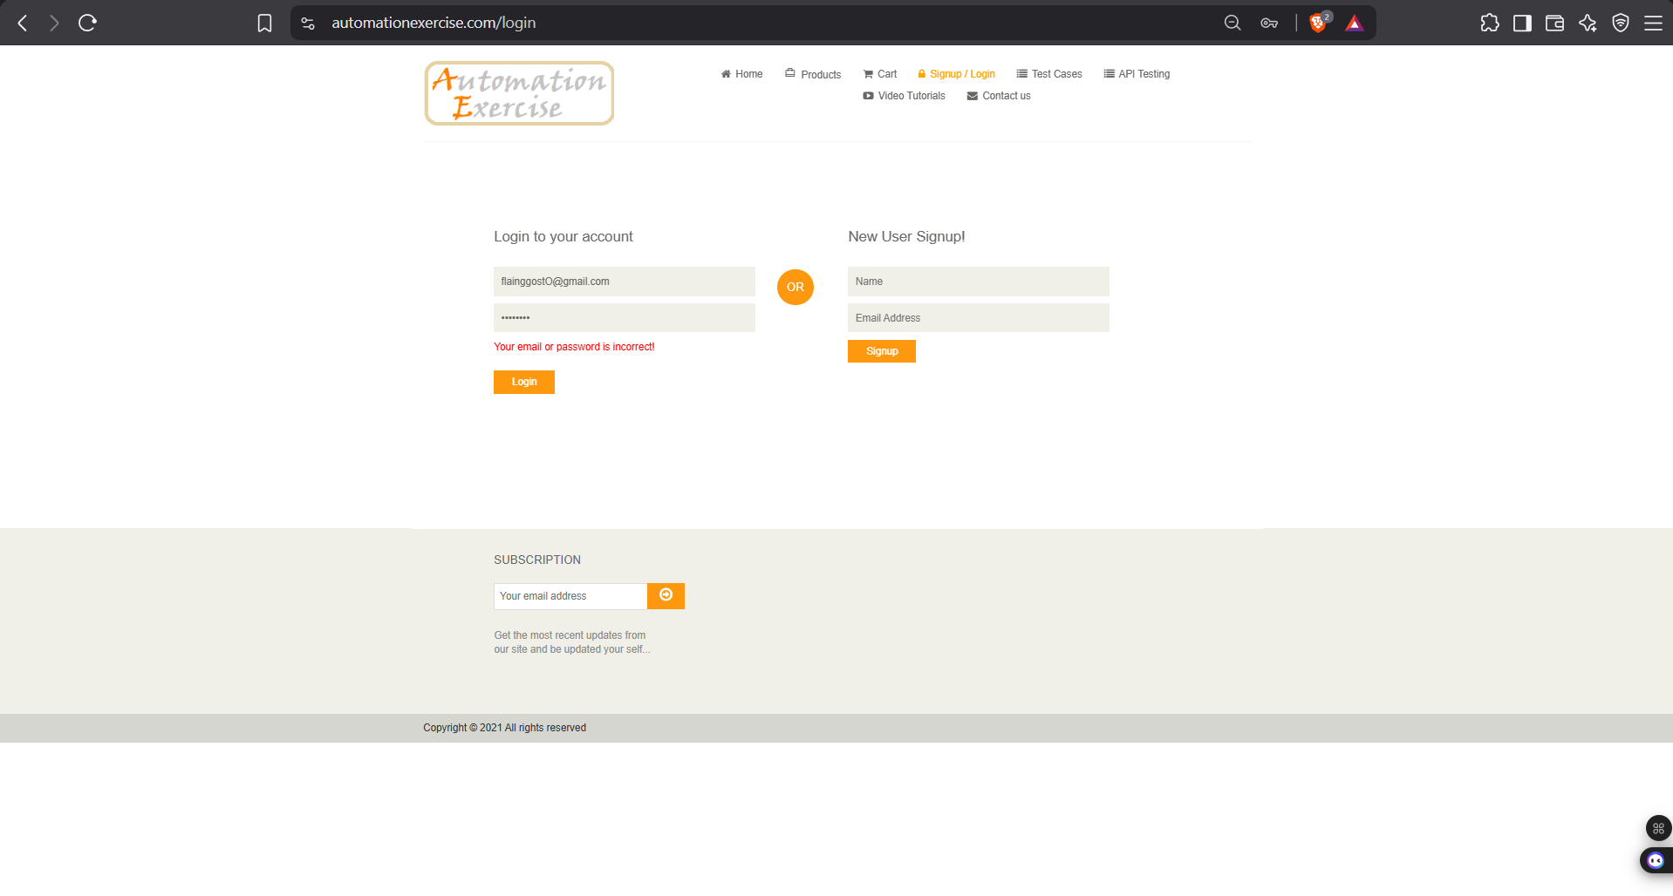

Scenario ID: TC-003
Scenario: Login Module
Test Steps: Verify login with empty email and password fields
Test Input: Email: (blank)
Password: (blank)
Expected Results: Validation message should appear asking to fill required fields. Form should not submit.
Actual Results: Browser default validation appeared (Please fill out this field). Form did not submit.
Status: Pass
Comments: Uses HTML5 validation. Suggestion: Add custom red error messages for better consistency with site design.

Scenario ID: TC-004
Scenario: Signup Module
Test Steps: Verify new user registration with valid data
Test Input: Name: John Doe
Email: johndoe2026@test.com
Password: Secure@123
Other details filled correctly
Expected Results: Account should be created successfully. User should be redirected to Account Created page with confirmation message.
Actual Results: Account created successfully. 'ACCOUNT CREATED!' message shown with Continue button.
Status: Pass
Comments: Registration flow is smooth. Suggestion: Add password strength indicator for better security awareness.
Screenshots:
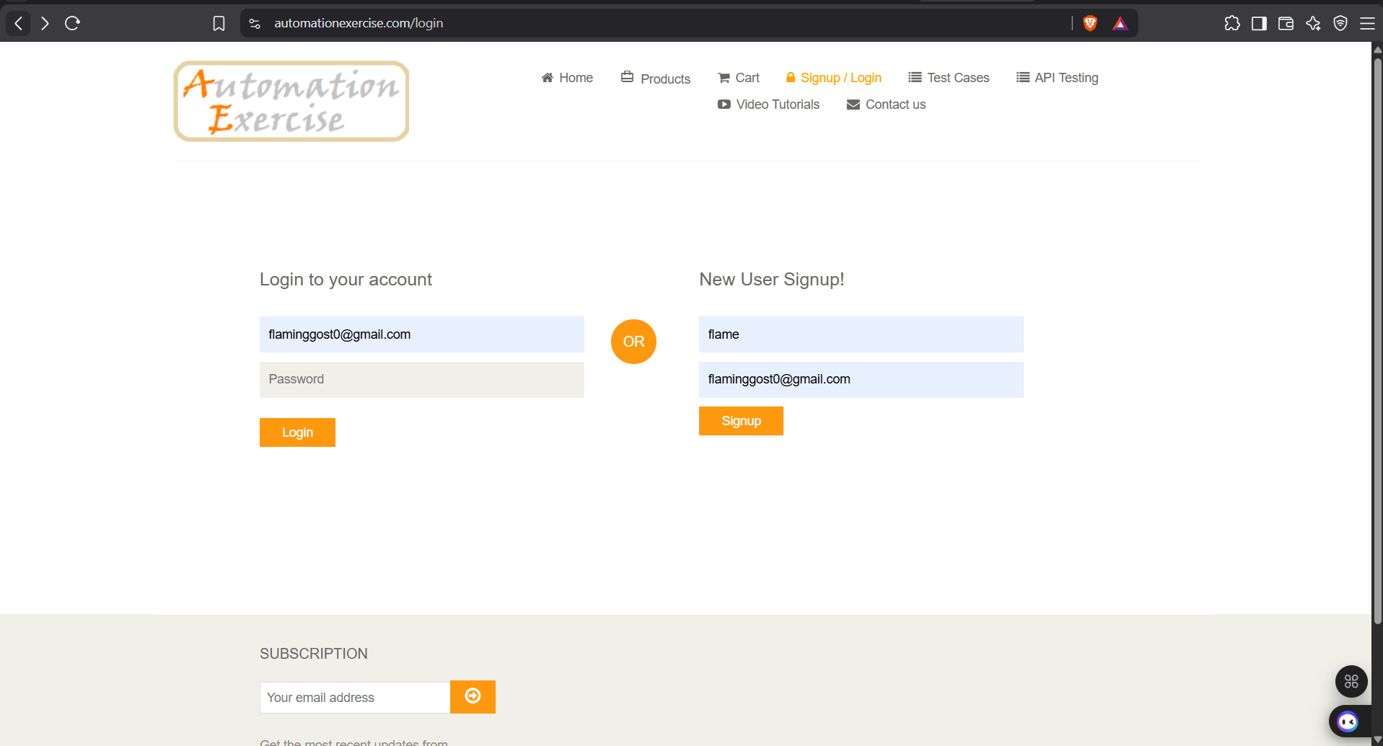
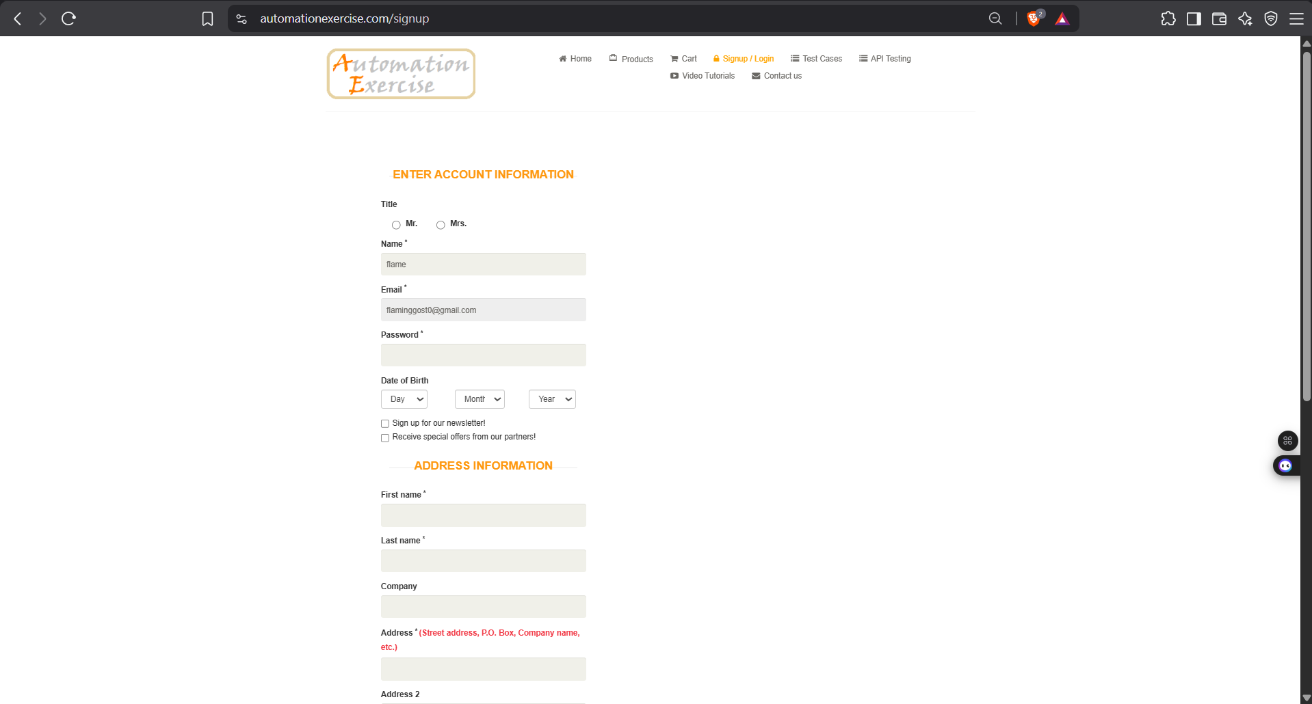

Scenario ID: TC-005
Scenario: Signup Module
Test Steps: Verify registration with already existing email
Test Input: Name: Test User
Email: testuser@example.com (already registered)
Expected Results: Error message 'Email Address already exist!' should be displayed.
Actual Results: Error message 'Email Address already exist!' appeared correctly.
Status: Pass
Comments: Proper duplicate email check is implemented. Good.

Scenario ID: TC-006
Scenario: Products Module
Test Steps: Verify product listing page loads correctly
Test Input: Navigate to Products page from menu
Expected Results: All products should be displayed with name, price, and 'Add to cart' button. Page should load without errors.
Actual Results: Products page loaded successfully. Multiple products visible with prices and Add to cart buttons.
Status: Pass
Comments: Page loads fast. Product cards are well designed. Suggestion: Add sorting by price/popularity.
Screenshots:
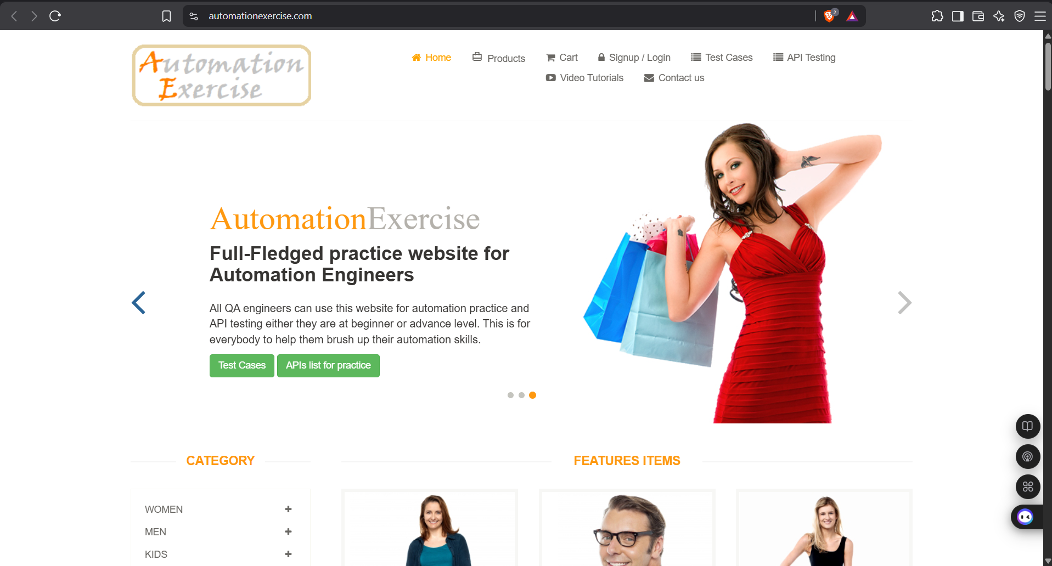
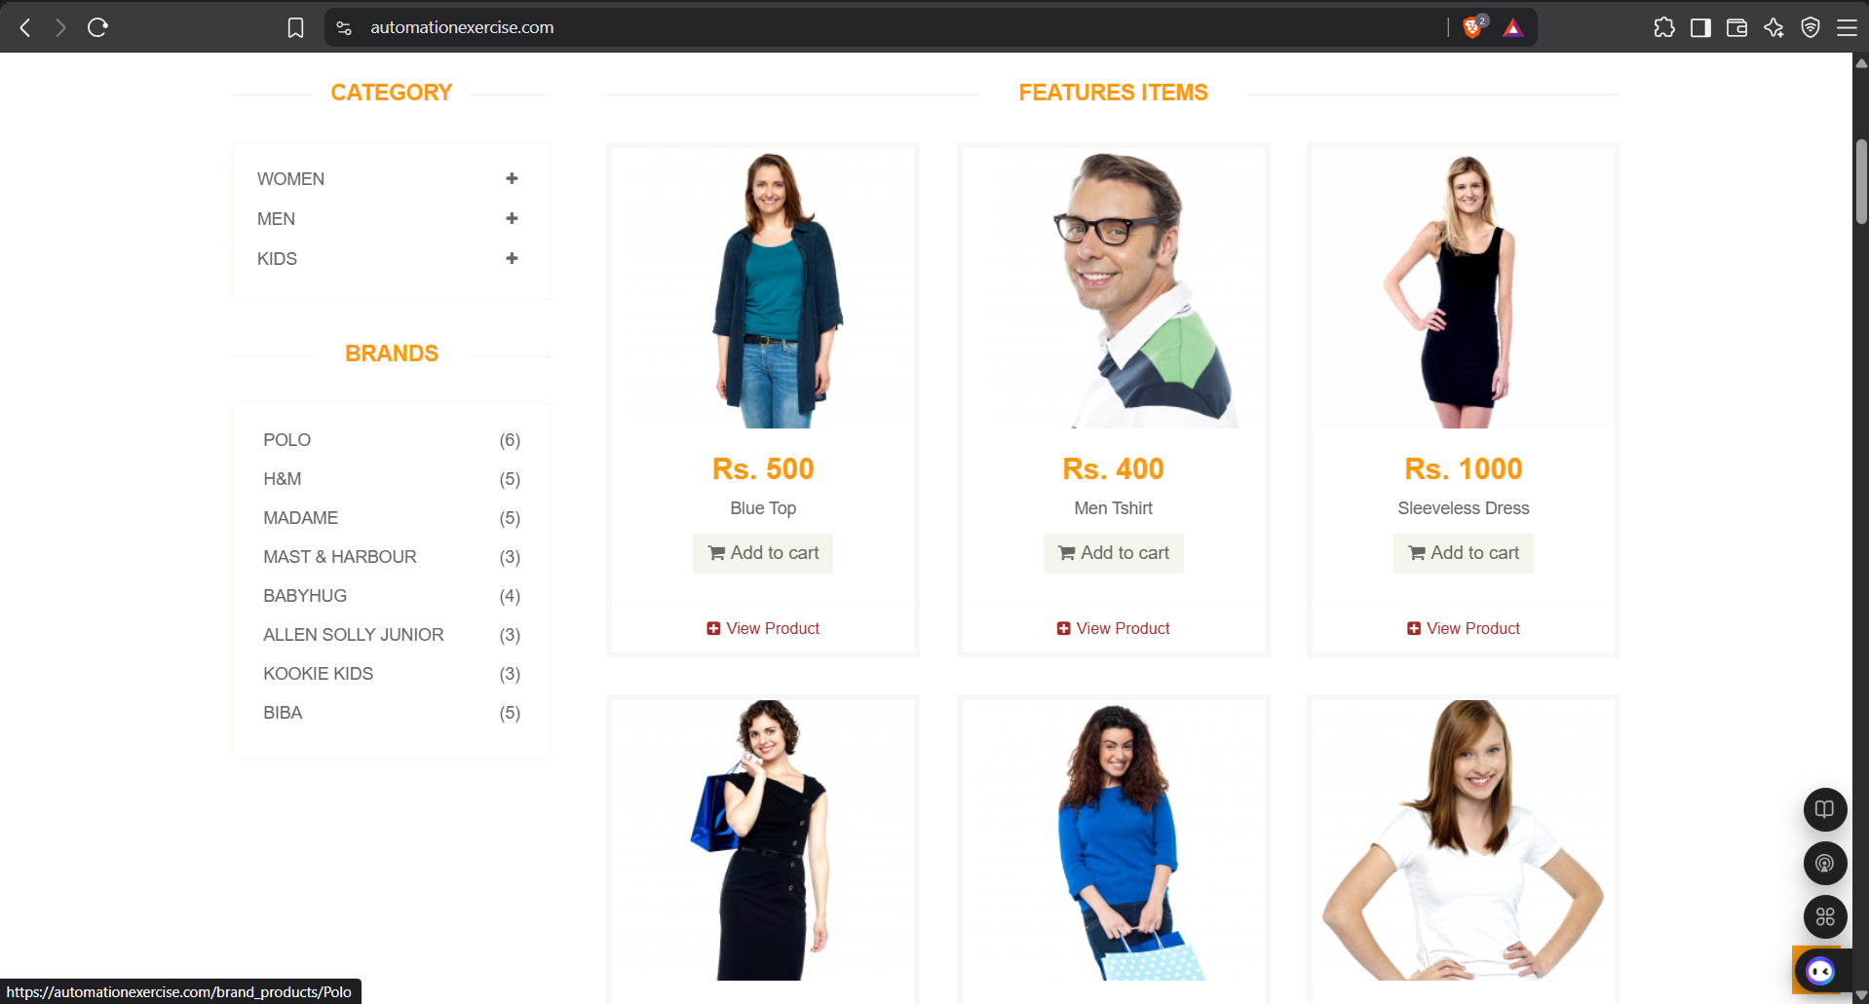

Scenario ID: TC-007
Scenario: Products Module
Test Steps: Verify search functionality with valid product name
Test Input: Search keyword: 'Blue Top'
Expected Results: Relevant products matching 'Blue Top' should be displayed in search results.
Actual Results: Search results showed 'Blue Top' product correctly.
Status: Pass
Comments: Search works accurately. Suggestion: Add autocomplete/suggestions while typing.

Scenario ID: TC-008
Scenario: Products Module
Test Steps: Verify search with invalid/non-existing product
Test Input: Search keyword: 'xyzabc123'
Expected Results: Message 'No products found' or empty results should be shown.
Actual Results: No products displayed. Empty state handled.
Status: Pass
Comments: Empty state is handled but could show a clearer 'No products found matching your search' message.

Scenario ID: TC-009
Scenario: Cart Module
Test Steps: Verify adding a product to cart
Test Input: Click 'Add to cart' on any product from Products page
Expected Results: Product should be added to cart. Cart count should increase. Success message 'Added!' should appear.
Actual Results: Product added successfully. Cart icon updated. 'Added!' popup appeared.
Status: Pass
Comments: Add to cart feedback is immediate and clear. Excellent UX.
Screenshots:
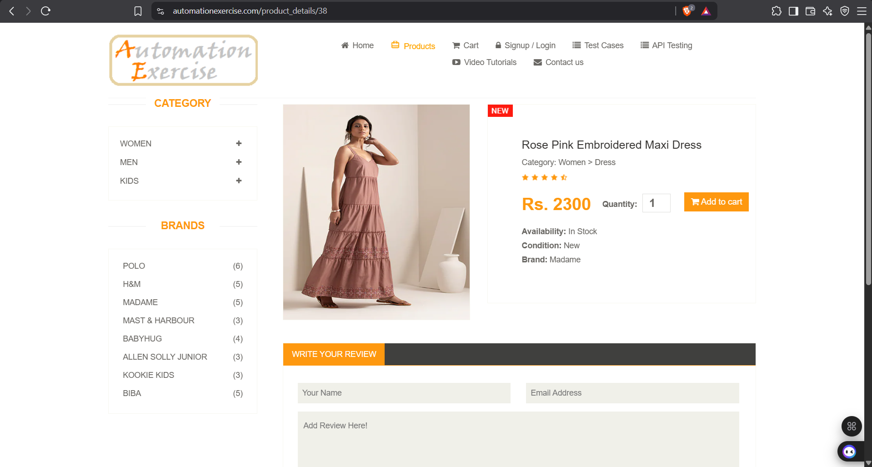

Scenario ID: TC-010
Scenario: Cart Module
Test Steps: Verify cart page displays correct product details
Test Input: Navigate to Cart after adding product
Expected Results: Cart should show product name, price, quantity, total price correctly.
Actual Results: Cart page displayed correct product name, price, quantity=1 and total amount.
Status: Pass
Comments: Cart calculation is accurate. Suggestion: Allow quantity update directly from cart with +/- buttons more prominently.
Screenshots:
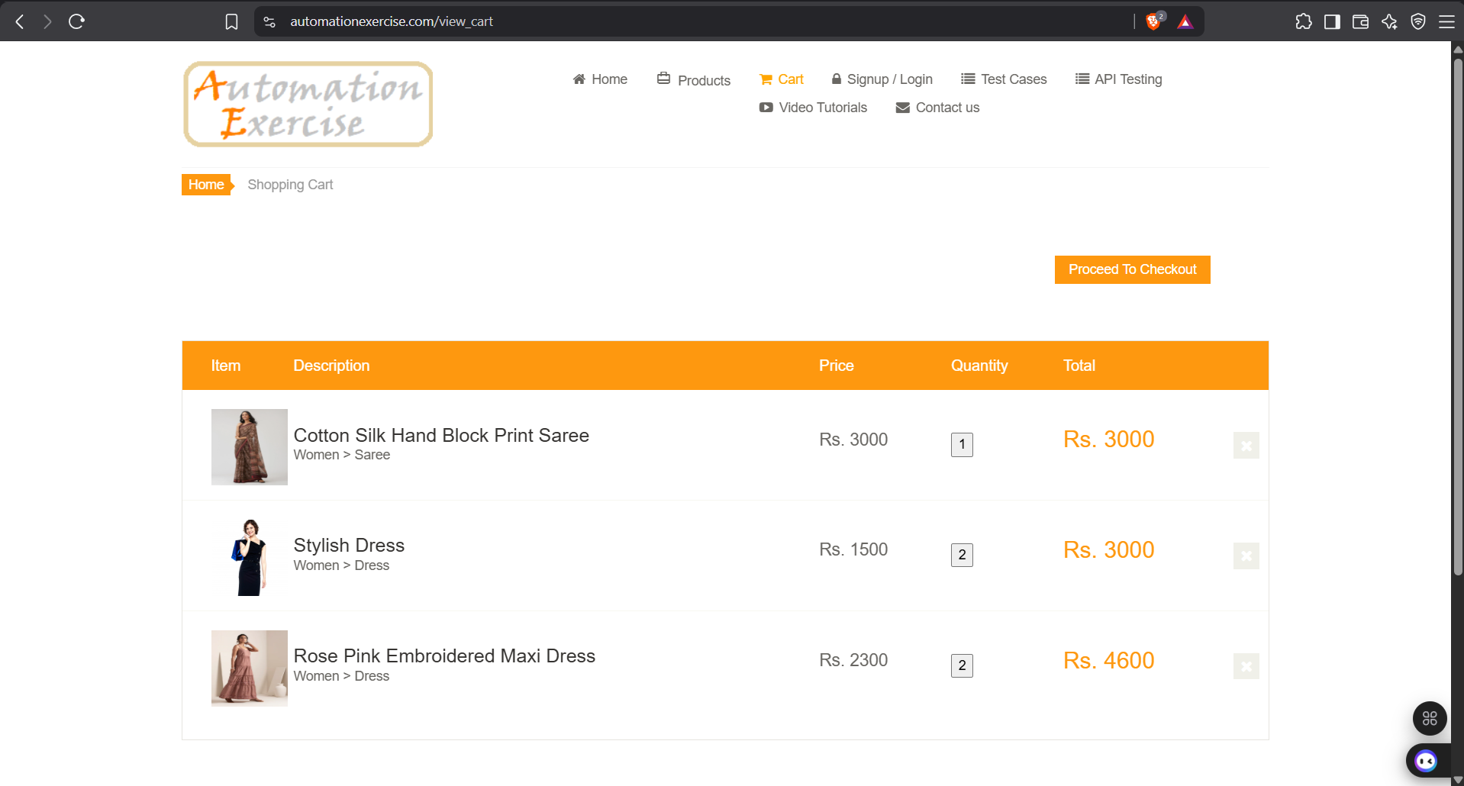

Scenario ID: TC-011
Scenario: Cart Module
Test Steps: Verify removing product from cart
Test Input: Click 'X' / Remove on a product in cart
Expected Results: Product should be removed from cart. Cart total should update. Empty cart message if no items left.
Actual Results: Product removed successfully. Cart became empty with appropriate message.
Status: Pass
Comments: Remove functionality works well.

Scenario ID: TC-012
Scenario: Checkout Module
Test Steps: Verify proceeding to checkout with items in cart
Test Input: Click 'Proceed To Checkout' from Cart page
Expected Results: User should be taken to Checkout page showing address details and order review.
Actual Results: Redirected to Checkout page. Address and order summary displayed correctly.
Status: Pass
Comments: Checkout flow is logical. Good separation of review and payment.

Scenario ID: TC-013
Scenario: Checkout Module
Test Steps: Verify placing order with valid payment details
Test Input: Fill payment details (Name on Card, Card Number, CVC, Expiry) and click 'Pay and Confirm Order'
Expected Results: Order should be placed successfully. 'ORDER PLACED!' confirmation message should appear.
Actual Results: Order placed successfully. Confirmation page with 'ORDER PLACED!' message displayed.
Status: Pass
Comments: Payment form is simple. Note: This is a demo site so no real payment is processed. Good for testing.
Screenshots:
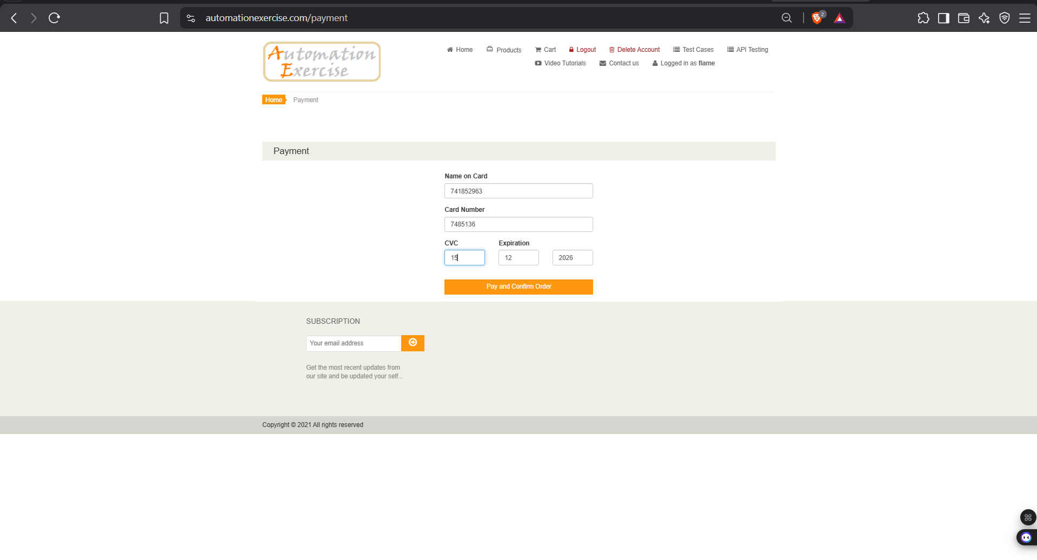

Scenario ID: TC-014
Scenario: Contact Us Module
Test Steps: Verify Contact Us form submission with valid data
Test Input: Name: Tester
Email: tester@test.com
Subject: Query
Message: Testing contact form
Upload file (optional)
Expected Results: Success message 'Success! Your details have been submitted successfully.' should appear.
Actual Results: Success message displayed correctly after submission.
Status: Pass
Comments: Contact form works. File upload also accepted. Suggestion: Add character limit indicator for message field.
Screenshots:
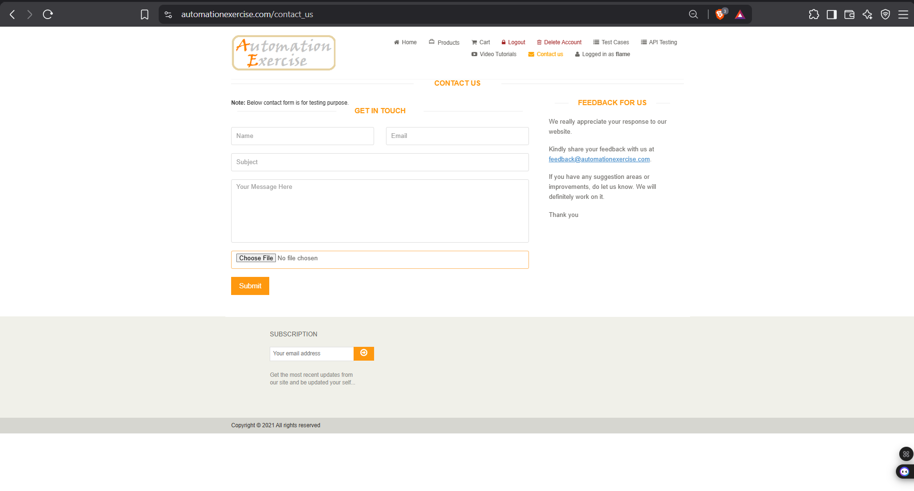

Scenario ID: TC-015
Scenario: Navigation
Test Steps: Verify Logout functionality
Test Input: Click Logout from top navigation after login
Expected Results: User should be logged out and redirected to login page. Session should end.
Actual Results: Logged out successfully. Redirected to login page. Session cleared.
Status: Pass
Comments: Logout works correctly. Clean session handling.

